**Airlines Data Analytics for Aviation Industry**

**IBM PROJECT-PNT2022TMID41005**

**NALAIYA THIRAN PROJECT BASED LEARNING ON**

# PROFESSIONAL READLINESS FOR INNOVATION, EMPLOYNMENT AND ENTERPRENEURSHIP

# A PROJECT REPORT

**G. Swetha-611819205030**

**N. Tamiya Anjum**-**611819205033**

**K. Minithasri**-**611819205013**

**J. Manjula**-**611819205012**

# BACHELOR OF INFORMATION TECHNOLOGY

**PSV COLLEGE OF ENGINEERING AND TECHNOLOGY**

# 

**Airlines Data Analytics for Avaition Industry**

**INTRODUCTION:**

**PROJECT OVERVIEW:**

* Users create multiple analytical graphs/charts/Visualizations.
* Using the Analytical Visualizations, build the required Dashboard(s).
* Saving and visualizing the final dashboard in the IBM Cognos Analytics.

**PURPOSE:**

To provide better Airline and AirPort services and to avoid delays in Air Travel across different locations at Municipality level. The aim is to provide airports, airlines, and the travelling public with a neutral, third-party view of which airlines are delivering on their promise to get passengers from Point A to Point B on-time.

**LITERATURE SURVEY:**

**EXISTING PROBLEM:**

The airport codes may refer to either the IATA airport code, a three-letter code that is used in passenger reservation, ticketing and baggage?handling systems, or the ICAO airport code which is a four-letter code used by ATC systems and for airports that do not have an IATA airport code.

**REFERENCES:**

1.Data Science And Analytics In Aviation(2020): Authors:Sai-Ho-Chung,Hoi-Lam-ma

2.Data Analytics for Air Travel Data(2021): Authors:Haiman Tian,Yudong Tao

3.Topological Data Analysis For Aviation Applications(2018): Authors: Max Z. Li,Megan S. Ryerson and Hamsa Balakrishnan

4.Operational Efficiency Versus Financial Mobility In The Global Airline Industry(2015): Author:Hoi-Lam-ma

5.An Evaluation Of The Operational Performance And Profitability Of The U.S. Airlines(2021): Author:Emillio Collar.

**PROBLEM STATEMENT DEFINITION:**

To identify and manage many people traveling this summer, they are noticing first –hand that airlines are facing major challenges, including numerous flight cancellations and delays.

**IDEATION & PROPOSED SOLUTION:**

**Empathy Map Canvas:**

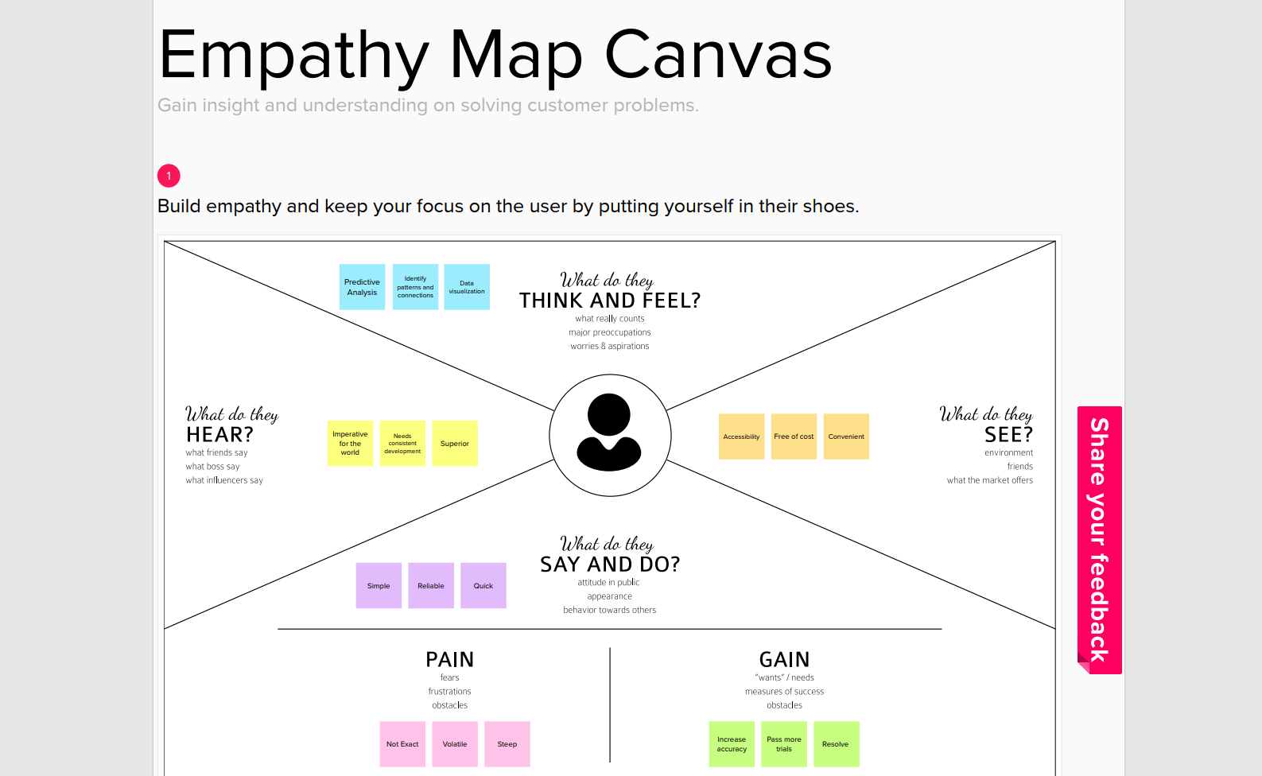

**Ideation & Brainstorming:**

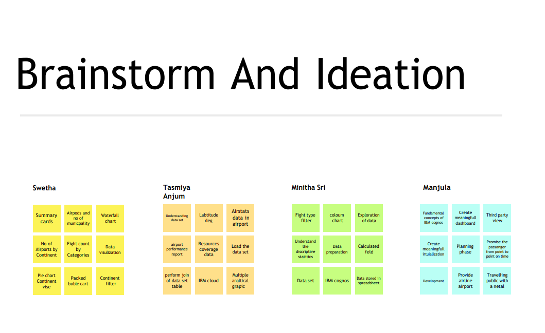

**Proposed Solution:**

|  |  |  |
| --- | --- | --- |
| **S.No.** | **Parameter** | **Description** |
| **1** | Problem Statement (Problem to be solved) | ❖ With the growing demand for air transportation and the limited ability to increase capacity at some key points in the air transportation system, there are concerns that in the future the system will not scale to meet demand.This situation will result in the generation and the propagation of delays throughout the system, impacting passengers’ quality of travel and more broadly the economy. |
| **2** | Idea / Solution description | ❖ Understanding traveler demand for specific city pairs and pricing flights can be done using data analytics project.  ❖ Airlines use this biometric technology as a boarding option. The equipment scans travelers’ faces and matches them with photos stored in border control agency databases. These can be handled with the aforementioned project. |
| **3** | Novelty / Uniqueness | ❖ The ultimate benefits of big data analytics include timely responses to current and future market demands, improved planning and strategically aligned decision making, as well as crystal clear comprehension and monitoring of all main performance drivers relevant to the airline industry.  ❖ Due to the use of smart data analytics, passengers will avoid many issues with baggage tracking. While radio?frequency identification prevents mishandling the baggage, predictive analysis assists in improving the predictability of fleet reliability. |
| **4** | Social Impact / Customer Satisfaction | ❖ Data analytics helps the industry to understand customers’ preferences and other maintenance issues.  ❖ For instance, analysis of ticket booking helps the industry to target the customers with personalised offers while optimising the price in real-time using predictive analysis techniques. As a result, by gathering meaningful data, airlines can fetch more bookings in the given timeframe. |
| **5** | Business Model (Revenue Model) | ❖ Business models innovation in airlines can contribute to the creation of value, competitive advantage and profitability with new possibilities of action.  ❖ A revenue model is a blueprint that shows how a startup business will earn revenue or gross income from its standard business operations, and how it will pay for operating costs and expenses |
| **6** | Scalability of the Solution | ❖ The Cloud Cognos Analytics is not only for particular organization/governments.  ❖ Aviation industry acting under international, domestic or private are also getting satisfied with the aviation data analysing process provided as per their needs |

**PROBLEM SOLUTION FIT:**

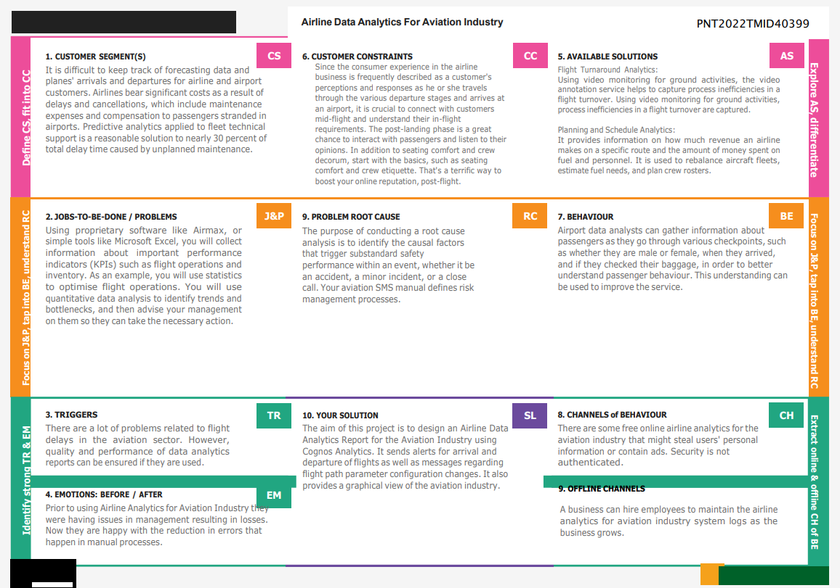

**REQUIREMENT ANALYSIS:**

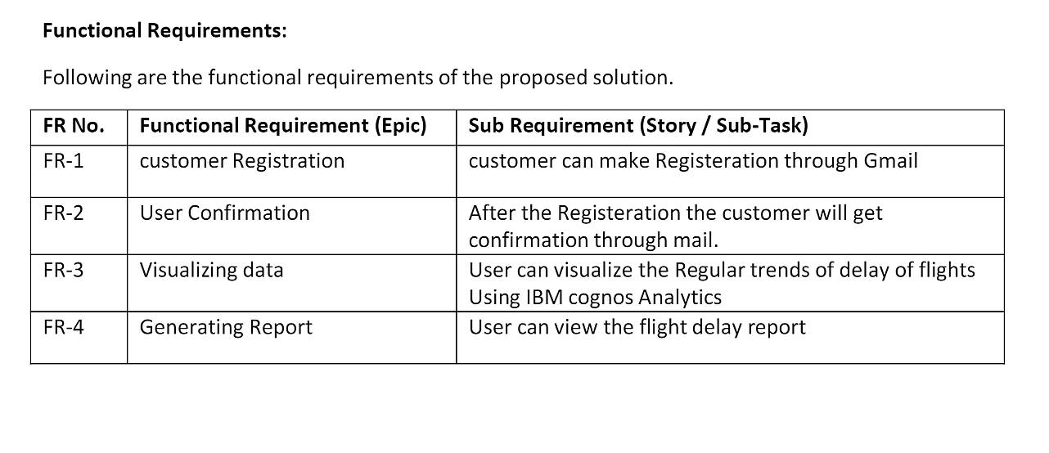

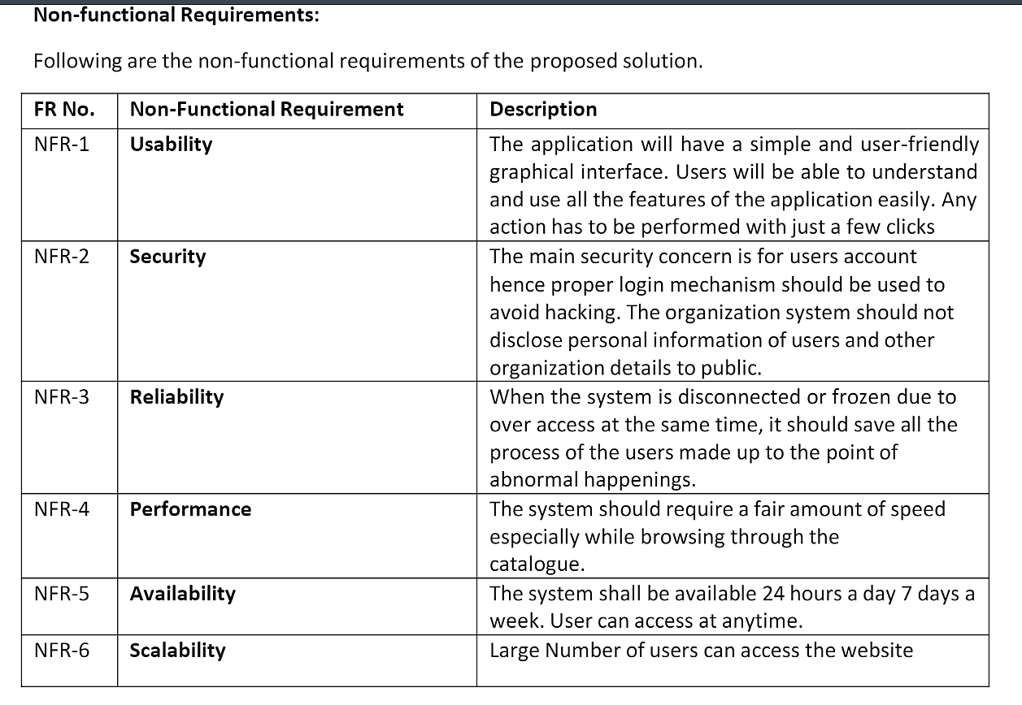

**PROJECT DESIGN:**

**Data Flow Diagrams**

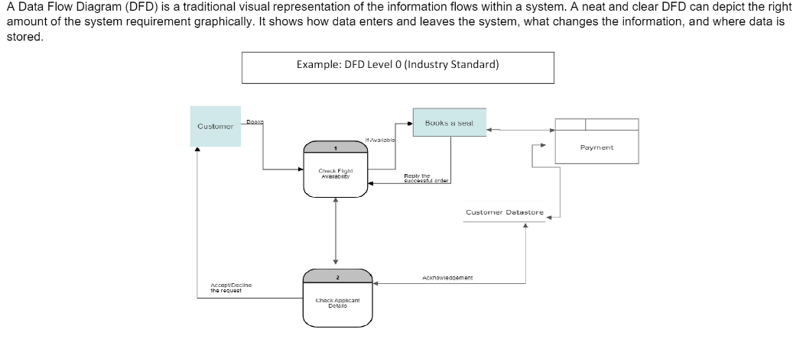

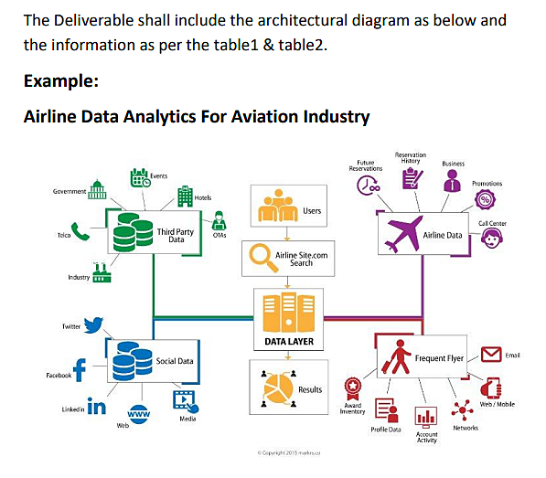

**USER STORIES:**

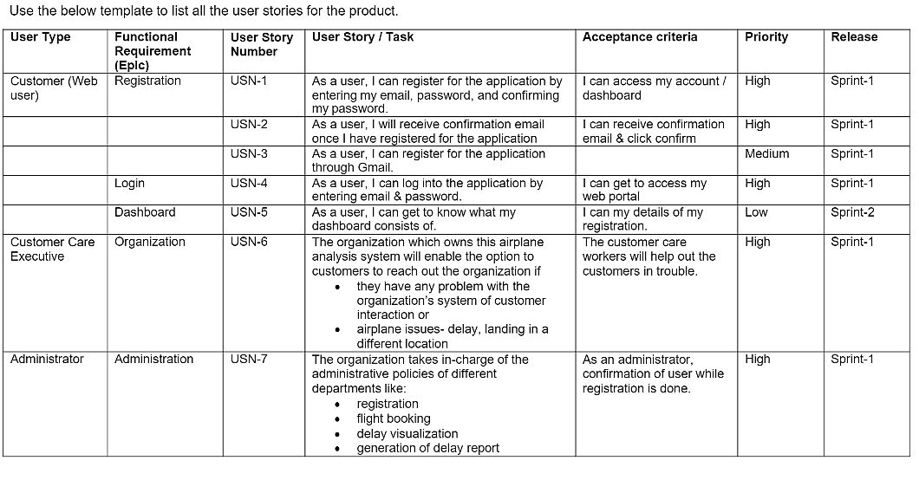

**PROJECT PLANNING & SCHEDULING:**

**Sprint Planning & Estimation:**

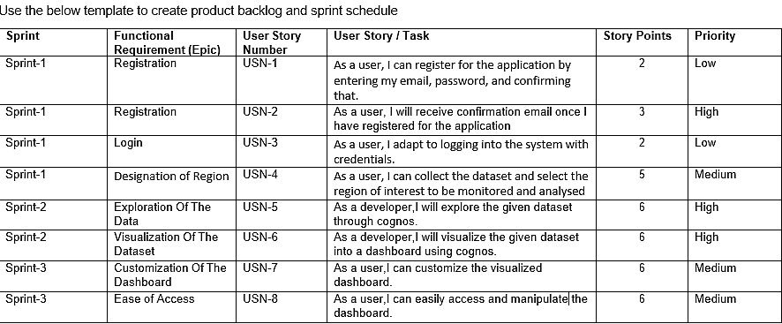



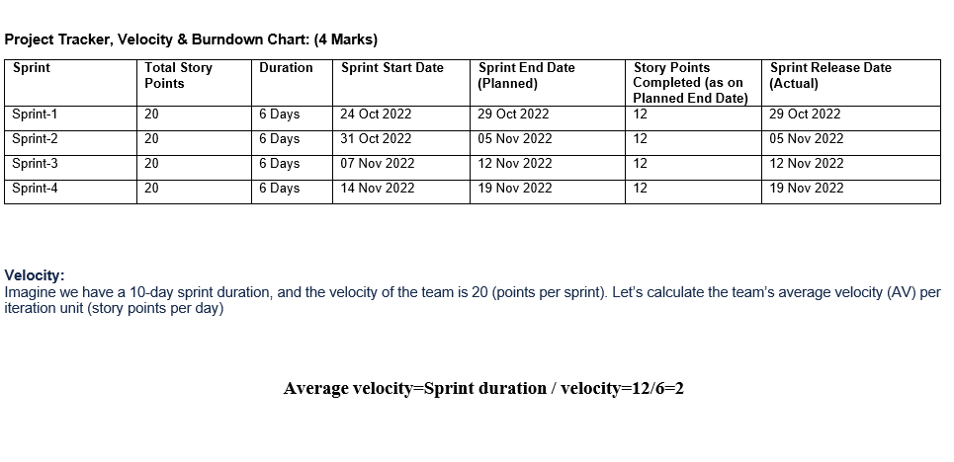

**Sprint Delivery Schedule:**

A milestone schedule, or milestone chart, is a timeline that uses milestones to divide a project schedule into major phases. A

milestone chart is a way to visualize the most important steps of our project. Each milestone the team achieves brings us closer to

completing the project. As a result, milestones provide a sense of accomplishment and show the team how the work they’re doing

contributes to the overarching project objective.

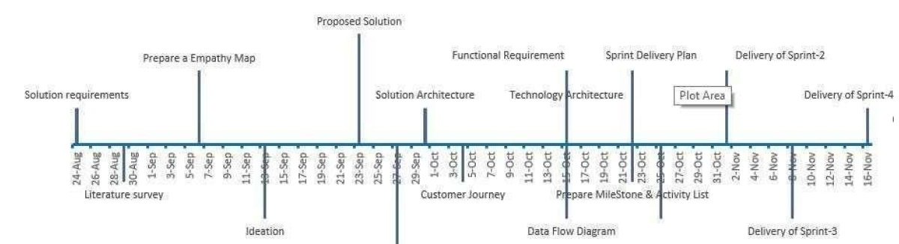

**Reports from JIRA:**

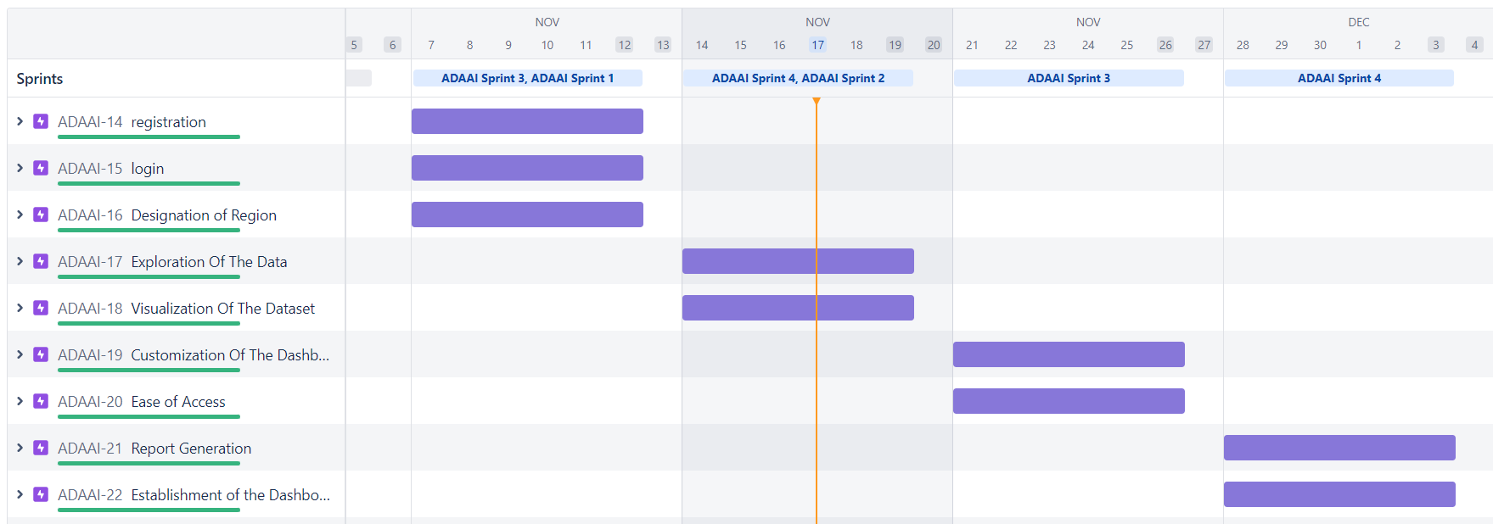

**WORKING WITH THE DATASET AND DATA VISUALIZATION:**

**Working with the dataset:**

* Understand the Dataset
* Load the Dataset
* Perform Joins of the Dataset tables

### Understanding The Dataset:

The data can be downloaded from the Links :

1. [AirStats data on airports around the world](https://www.kaggle.com/patrasaurabh/airstats-data-on-airports-around-the-world)
2. [Circum - Airport Performance Reports](https://www.cirium.com/studios/on-time-performance/)
3. [Resources Coverage data](https://www.flightstats.com/v2/resources/coverage-data)

* Airports.csv

|  |  |  |
| --- | --- | --- |
| # | Field Name | Data Type |
| 1 | id | Int |
| 2 | ident | Text |
| 3 | type | Text |
| 4 | name | Text |
| 5 | latitude_deg | Geo |
| 6 | longitude_deg | Geo |
| 7 | elevation_ft | int |
| 8 | continent | Text |
| 9 | iso_country | Text |
| 10 | iso_region | Text |
| 11 | municipality | Text |
| 12 | scheduled_service | Boolean |
| 13 | gps_code | Text |
| 14 | iata_code | Text |
| 15 | local_code | Text |
| 16 | home_link | Text |
| 17 | wikipedia_link | Text |
| 18 | keywords | Text |
|  |  |  |

* Countries.csv

|  |  |  |
| --- | --- | --- |
| # | Field Name | Type |
| 1 | id | Int |
| 2 | code | Text |
| 3 | name | Text |
| 4 | continent | Text |
| 5 | wikipedia_link | Text |
| 6 | keywords | Text |

* Regions.csv

|  |  |  |
| --- | --- | --- |
| # | Field Name | Type |
| 1 | id | Int |
| 2 | code | Text |
| 3 | local_code | Text |
| 4 | name | Text |
| 5 | continent | Text |
| 6 | iso_country | Text |
| 7 | wikipedia_link | Text |
| 8 | keywords | Text |

**DATASET LINK:**

<https://www.kaggle.com/patrasaurabh/airstats-data-on-airports-around-the-world>

### Loading Of Dataset

Before you build a view and analyze your data, you must first connect the data to IBM Cognos. Cognos supports connecting to a wide variety of data, stored in a variety of places.  
  
The data might be stored on your computer in a spreadsheet or a text file, or in a big data, relational, or cube (multidimensional) database on a server in your enterprise.  
  
In our case, we will be using a spreadsheet or text file for making our analysis.

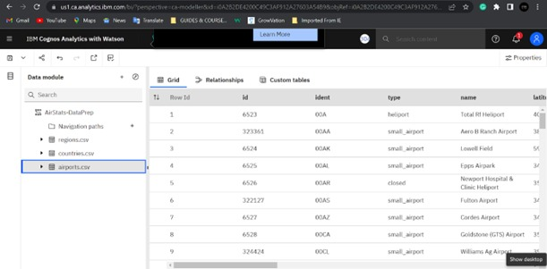

### Data Preparation:

- Validate all the tables - airports, countries, regions

- Create calculated field - Continent Name using the codes.///*-*+-oining Of Tables:

Joining of Tables Airports, Countries and Regions with the related columns.

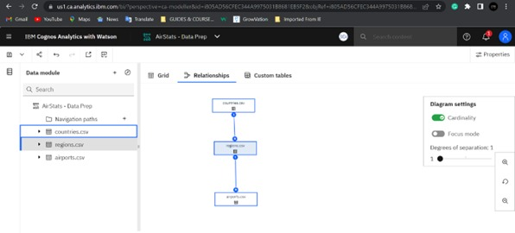

**EXPLORATION OF DATA:**

* Explore from data directly or via an existing asset in a Dashboard or Story
* Leverage advanced analytics in an accessible way, opening the door for any user to surface compelling new insights
* Interact with contextual recommendations that guide users to greater understanding of their data
* Start exploring immediately with an intuitive, natural language tool that lowers the barriers to entry for the world of analytics.

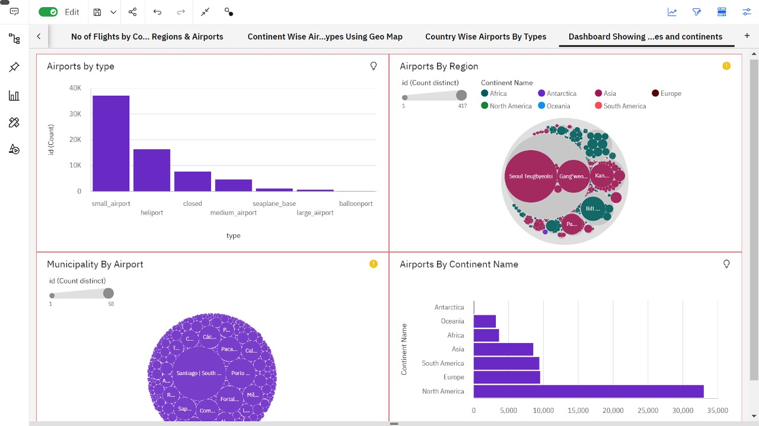

**DATA VISUALIZATION:**

Using the given dataset, we plan to create various graphs and charts to highlight the insights and visualizations.

### Representation Of Flight Count By Categories

1. Pie Chart - Continent-wise No. of Flights  
2. Packed Bubble Chart - Continent wise No. of Flights by Type - Colored with Type  
3. Continent List - Filter  
4. Top 10 Countries by Flights

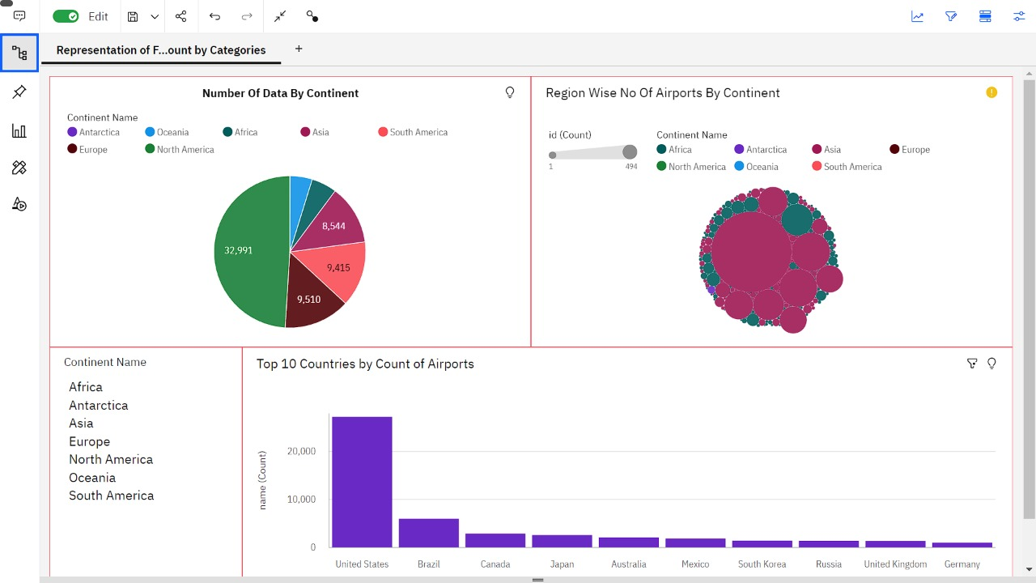

### No Of Flights By Countries , Regions And Airports

1. Countries - Summary Card  
2. Regions - Summary Card  
3. Airports - Summary Card  
4. Municipalities - Summary Card  
5. Column Chart - Continent-wise No of Flights  
6. Waterfall-Chart - Continent-wise No of Flights

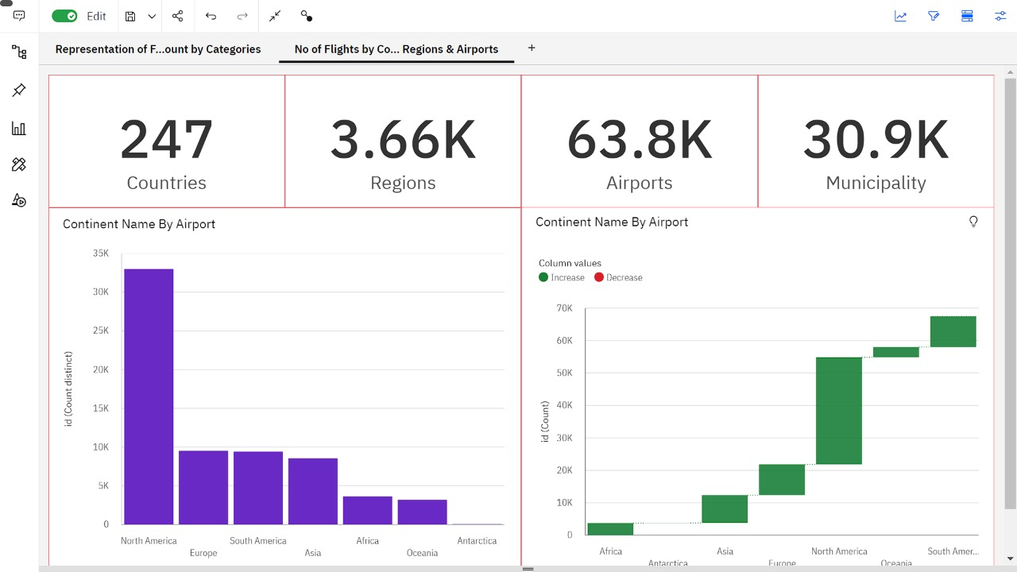

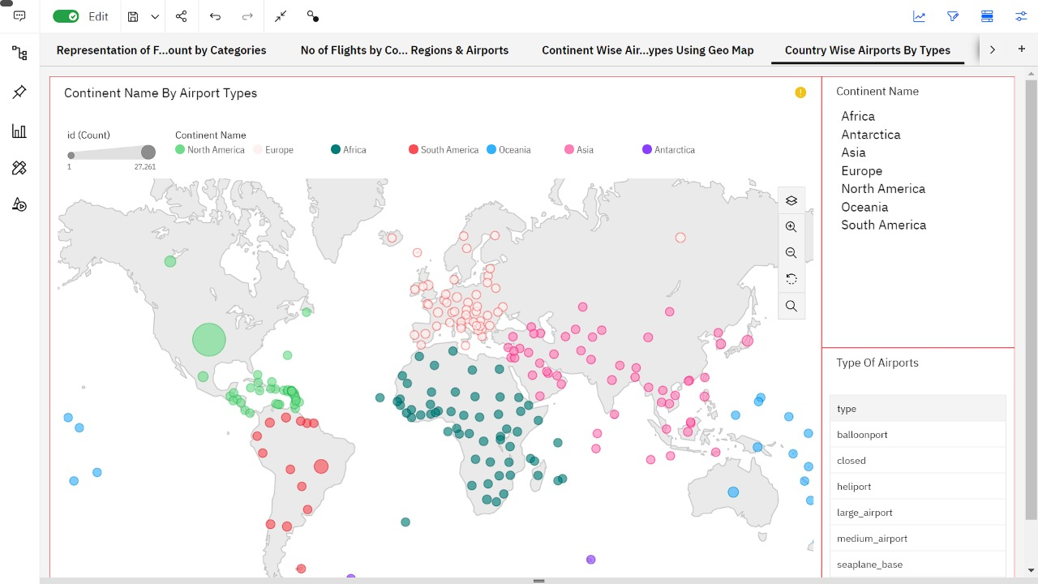

Country Wise Airports With Types

1. Geo-Map - Country-wise No. of flights  
2.. Continent Filter  
3. Flight-Type filter

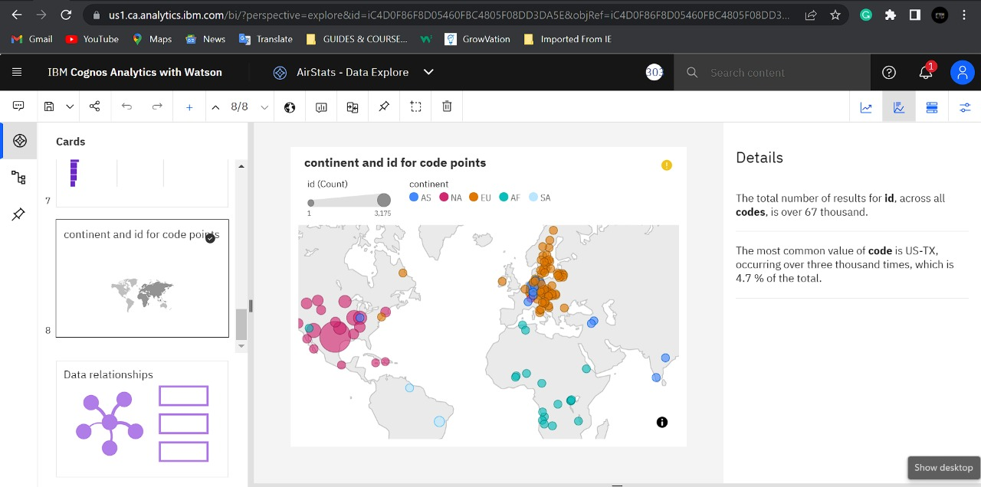

### Dashboard showing count of flights by Types,Countries and Continents:

1. Column-Chart - No of Airports by Type  
2. Hierarchy Bubble Chart - Region-wise Different Types of Airports  
3. Packed bubble Chart - Municipality-wise No. of Airports  
4. Bar Chart - Continent-wise No of Airports

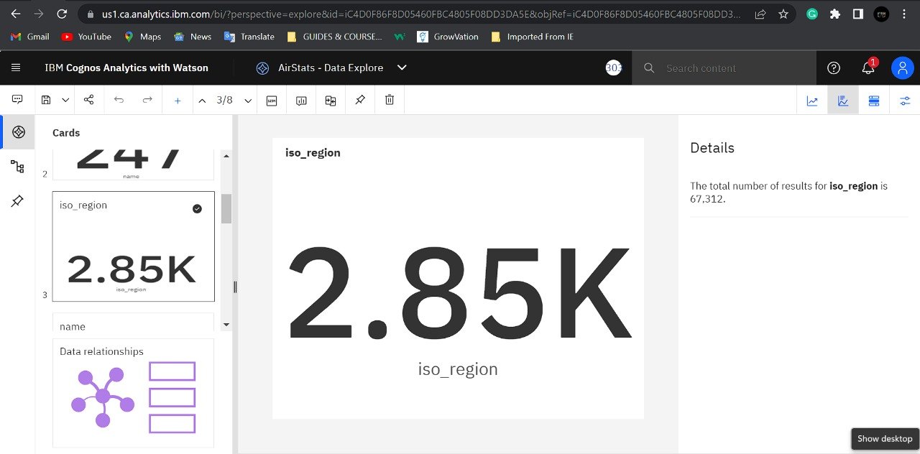

**TESTING:**

**Test Cases:**

|  |  |  |  |  |  |  |  |
| --- | --- | --- | --- | --- | --- | --- | --- |
| **Test case ID** | **Feature Type** | **Component** | **Test Scenario** | **Steps To Execute** | **Expected Result** | **Actual Result** | **Status** |
| LoginPage_TC_OO1 | Functional | Home Page | Verify user is able to see the Login/Signup popup when user clicked on My account button | 1.Enter URL and click go 2.Click on My Account dropdown button 3.Verify login/Singup popup displayed or not | Login/Signup popup should display | Working as expected | Pass |
| LoginPage_TC_OO2 | UI | Dashboard page | Verify user is able to see airport report in dashboard page | 1.Airstat dashboard will be displayed.  2.Check if each tab can able to access.  3.Click on the required dataset.  4.Obtain the report. | Required visualization will be displayed on the dashboard. | Working as expected. | Pass |

**USER ACCEPTANCE TESTING:**

# Defect Analysis:

# This report shows the number of resolved or closed bugs at each severity level, and how they were resolved.

|  |  |  |  |  |  |
| --- | --- | --- | --- | --- | --- |
| **Resolution** | **Severity 1** | **Severity 2** | **Severity 3** | **Severity 4** | **Subtotal** |
| By Design | 10 | 4 | 2 | 3 | 20 |
| Duplicate | 1 | 0 | 3 | 0 | 4 |
| External | 2 | 3 | 0 | 1 | 6 |
| Fixed | 11 | 2 | 4 | 20 | 37 |
| Not Reproduced | 0 | 0 | 1 | 0 | 1 |
| Skipped | 0 | 0 | 1 | 1 | 2 |
| Won't Fix | 0 | 5 | 2 | 1 | 8 |
| Totals | 24 | 14 | 13 | 26 | 77 |

# Test Case Analysis

This report shows the number of test cases that have passed, failed, and untested

|  |  |  |  |  |
| --- | --- | --- | --- | --- |
| **Section** | **Total Cases** | **Not Tested** | **Fail** | **Pass** |
| Print Engine | 7 | 0 | 0 | 7 |
| Client Application | 51 | 0 | 0 | 51 |
| Security | 2 | 0 | 0 | 2 |
| Outsource Shipping | 3 | 0 | 0 | 3 |
| Exception Reporting | 9 | 0 | 0 | 9 |
| Final Report Output | 4 | 0 | 0 | 4 |
| Version Control | 2 | 0 | 0 | 2 |

**RESULTS:**

**PERFORMANCE METRICS:**

**Model Performance Testing:**

Project team shall fill the following information in model performance testing template.

|  |  |  |
| --- | --- | --- |
| **S.No.** | **Parameter** | **Screenshot / Values** |
|  | Dashboard design | No of Visulizations / Graphs - 18 |
|  | Data Responsiveness | It shows the output when any of the dataset is selected. |
| 3. | Utilization of Data Filters | Various filter methods were used to filter the dataset values like sort,top or bottom,format data etc.. |
| 4. | Effective User Story | No of Tab Added - 5 |
| 5. | Descriptive Reports | No of Visulizations / Graphs - 18 |

**ADVANTAGES & DISADVANTAGES:**

**ADVANTAGES:**

* It improves the average turnaround time needed to cater to market trends.
* Properly implemented data modules help flight operators bag more customers and profits.
* Predictive analytics is the key to preparing for future crises and put a mitigation plan in place.
* It helps businesses make data-backed and more informed policy decisions.
* Not just sales and customer service, data analytics play a vital role in flight operations and maintenance too.

**DISADVANTAGES:**

* Air transport is a costly service. Its operational costs are too high. Middle class and poor people can not affect its cash.
* Air transport is prone to accidents. A small mistake can be very dangerous for passengers. Hijacking of planes is easily possible.
* For creating aviation facilities, huge investments are required. The cost of aero planes, construction and maintenance of aerodromes and control mechanism needs a capital expenditure.

**CONCLUSION:**

Flight delays are a major problem in civil aviation. They incur direct and indirect costs, such as maintenance at the gate, extra fees for crew, food service, and lodging. They also affect passenger satisfaction. Flight delay is inevitable and it plays an important role in both

profits and losses of the airlines. An accurate estimation of flight delay is critical for airlines because the results can be applied to increase customer satisfaction and the incomes of airline agencies. So, the prediction and analysis of flight delays are of great significance to airlines, passengers, and airports. Predicting delays will help an airport to adjust resource allocations, quickly analyse the causes, and take measures to reduce or eliminate delays. Therefore, It delivers a well-friendly graphical UI and gives a proper delay rate to the users.

**FUTURE SCOPE**:

To illustrate, airlines bear high costs due to delays and cancellations that include expenses on maintenance and compensations to travellers stuck in airports. With nearly 30 % of the total delay time caused by unplanned maintenance, predictive analytics applied to fleet technical support is a reasonable solution.

**APPENDIX:**

**Source code:**

**Source code for login page:**

**<!DOCTYPE html**

**<!-- Code by CodeWithNepal - codewithnepal -->**

**<html lang="en">**

**<head>**

**<meta charset="UTF-8">**

**<meta name="viewport" content="width=device-width, initial-scale=1.0">**

**<title>Login Form validation using HTML CSS & JS | CodeWithNepal</title>**

**<link rel="stylesheet" href="style2.css">**

**<linkrel="stylesheet"href="https://cdnjs.cloudflare.com/ajax/libs/font-awesome/5.15.3/css/all.min.css"/>**

**<script type="sript2.js"></script>**

**</head>**

**<body>**

**<div class="wrapper">**

**<header>Login Form</header>**

**<form action="#">**

**<div class="field email">**

**<div class="input-area">**

**<input type="text" placeholder="Email Address">**

**<i class="icon fas fa-envelope"></i>**

**<i class="error error-icon fas fa-exclamation-circle"></i>**

**</div>**

**<div class="error error-txt">Email can't be blank</div>**

**</div>**

**<div class="field password">**

**<div class="input-area">**

**<input type="password" placeholder="Password">**

**<i class="icon fas fa-lock"></i>**

**<i class="error error-icon fas fa-exclamation-circle"></i>**

**</div>**

**<div class="error error-txt">Password can't be blank</div>**

**</div>**

**<div class="pass-txt"><a href="#">Forgot password?</a></div>**

**<input type="submit" value="Login">**

**</form>**

**<div class="sign-txt">Not yet member? <a href="#">Signup now</a></div>**

**</div><script src="script.js"></script>**

**/body>**

**</html>>**

**\*{**

**margin: 0;**

**padding: 0;**

**box-sizing: border-box;**

**font-family: "Poppins", sans-serif;**

**}**

**body{**

**width: 100%;**

**height: 100vh;**

**display: flex;**

**align-items: center;**

**justify-content: center;**

**background-image: url("flight.jpg");**

**background-repeat:no-repeat;**

**background-size:cover ;**

**}**

**::selection{**

**color: #fff;**

**background: #3853bf;**

**}**

**.wrapper{**

**width: 380px;**

**padding: 40px 30px 50px 30px;**

**background: #fff;**

**border-radius: 5px;**

**text-align: center;**

**box-shadow: 10px 10px 15px rgba(0,0,0,0.1);**

**}**

**.wrapper header{**

**font-size: 35px;**

**font-weight: 600;**

**}**

**.wrapper form{**

**margin: 40px 0;**

**}**

**form .field{**

**width: 100%;**

**margin-bottom: 20px;**

**}**

**form .field.shake{**

**animation: shake 0.3s ease-in-out;**

**}**

**@keyframes shake {**

**0%, 100%{**

**margin-left: 0px;**

**}**

**20%, 80%{**

**margin-left: -12px;**

**}**

**40%, 60%{**

**margin-left: 12px;**

**}**

**}**

**form .field .input-area{**

**height: 50px;**

**width: 100%;**

**position: relative;**

**}**

**form input{**

**width: 100%;**

**height: 100%;**

**outline: none;**

**padding: 0 45px;**

**font-size: 18px;**

**background: none;**

**caret-color: #5372F0;**

**border-radius: 5px;**

**border: 1px solid #bfbfbf;**

**border-bottom-width: 2px;**

**transition: all 0.2s ease;**

**}**

**form .field input:focus,**

**form .field.valid input{**

**border-color: #5372F0;**

**}**

**form .field.shake input,**

**form .field.error input{**

**border-color: #dc3545;**

**}**

**.field .input-area i{**

**position: absolute;**

**top: 50%;**

**font-size: 18px;**

**pointer-events: none;**

**transform: translateY(-50%);**

**}**

**.input-area .icon{**

**left: 15px;**

**color: #bfbfbf;**

**transition: color 0.2s ease;**

**}**

**.input-area .error-icon{**

**right: 15px;**

**color: #dc3545;**

**}**

**form input:focus ~ .icon,**

**form .field.valid .icon{**

**color: #5372F0;**

**}**

**form .field.shake input:focus ~ .icon,**

**form .field.error input:focus ~ .icon{**

**color: #bfbfbf;**

**}**

**form input::placeholder{**

**color: #bfbfbf;**

**font-size: 17px;**

**}**

**form .field .error-txt{**

**color: #dc3545;**

**text-align: left;**

**margin-top: 5px;**

**}**

**form .field .error{**

**display: none;**

**}**

**form .field.shake .error,**

**form .field.error .error{**

**display: block;**

**}**

**form .pass-txt{**

**text-align: left;**

**margin-top: -10px;**

**}**

**.wrapper a{**

**color: #5372F0;**

**text-decoration: none;**

**}**

**.wrapper a:hover{**

**text-decoration: underline;**

**}**

**form input[type="submit"]{**

**height: 50px;**

**margin-top: 30px;**

**color: #fff;**

**padding: 0;**

**border: none;**

**background: #5372F0;**

**cursor: pointer;**

**border-bottom: 2px solid rgba(0,0,0,0.1);**

**transition: all 0.3s ease;**

**}**

**form input[type="submit"]:hover{**

**background: #2c52ed;**

**};**

**[8:33 PM, 11/19/2022] Swetha G: const form = document.querySelector("form")**

**eField = form.querySelector(".email"),**

**eInput = eField.querySelector("input"),**

**pField = form.querySelector(".password"),**

**pInput = pField.querySelector("input");**

**form.onsubmit = (e)=>{**

**e.preventDefault(); //preventing from form submitting**

**//if email and password is blank then add shake class in it else call specified function**

**(eInput.value == "") ? eField.classList.add("shake", "error") : checkEmail();**

**(pInput.value == "") ? pField.classList.add("shake", "error") : checkPass();**

**setTimeout(()=>{ //remove shake class after 500ms**

**eField.classList.remove("shake");**

**pField.classList.remove("shake");**

**}, 500);**

**eInput.onkeyup = ()=>{checkEmail();} //calling checkEmail function on email input keyup**

**pInput.onkeyup = ()=>{checkPass();} //calling checkPassword function on pass input keyup**

**function checkEmail(){ //checkEmail function**

**let pattern = /^[^ ]+@[^ ]+\.[a-z]{2,3}$/; //pattern for validate email**

**if(!eInput.value.match(pattern)){ //if pattern not matched then add error and remove valid class**

**eField.classList.add("error");**

**eField.classList.remove("valid");**

**let errorTxt = eField.querySelector(".error-txt");**

**//if email value is not empty then show please enter valid email else show Email can't be blank**

**(eInput.value != "") ? errorTxt.innerText = "Enter a valid email address" : errorTxt.innerText = "Email can't be blank";**

**}else{ //if pattern matched then remove error and add valid class**

**eField.classList.remove("error");**

**eField.classList.add("valid");**

**}**

**}**

**function checkPass(){ //checkPass function**

**if(pInput.value == ""){ //if pass is empty then add error and remove valid class**

**pField.classList.add("error");**

**pField.classList.remove("valid");**

**}else{ //if pass is empty then remove error and add valid class**

**pField.classList.remove("error");**

**pField.classList.add("valid");**

**}**

**//if eField and pField doesn't contains error class that mean user filled details properly**

**if(!eField.classList.contains("error") && !pField.classList.contains("error")){**

**window.location.href = form.getAttribute("action"); //redirecting user to the specified url which is inside action attribute of form tag**

**}};**

**<!DOCTYPE html>**

**<html>**

**<head>**

**<meta charset="utf-8" />**

**<title>Responsive Registration Form</title>**

**<meta name="viewport" content="width=device-width,**

**initial-scale=1.0"/>**

**<link rel="stylesheet" href="style.css" />**

**</head>**

**<body>**

**<div class="container">**

**<h1 class="form-title">Registration</h1>**

**<form action="#">**

**<div class="main-user-info">**

**<div class="user-input-box">**

**<label for="fullName">Full Name</label>**

**<input type="text"**

**id="fullName"**

**name="fullName"**

**placeholder="Enter Full Name"/>**

**</div>**

**<div class="user-input-box">**

**<label for="username">Username</label>**

**<input type="text"**

**id="username"**

**name="username"**

**placeholder="Enter Username"/>**

**</div>**

**<div class="user-input-box">**

**<label for="email">Email</label>**

**<input type="email"**

**id="email"**

**name="email"**

**placeholder="Enter Email"/>**

**</div>**

**<div class="user-input-box">**

**<label for="phoneNumber">Phone Number</label>**

**<input type="text"**

**id="phoneNumber"**

**name="phoneNumber"**

**placeholder="Enter Phone Number"/>**

**</div>**

**<div class="user-input-box">**

**<label for="password">Password</label>**

**<input type="password"**

**id="password"**

**name="password"**

**placeholder="Enter Password"/>**

**</div>**

**<div class="user-input-box">**

**<label for="confirmPassword">Confirm Password</label>**

**<input type="password"**

**id="confirmPassword"**

**name="confirmPassword"**

**placeholder="Confirm Password"/>**

**</div>**

**</div>**

**<div class="gender-details-box">**

**<span class="gender-title">Gender</span>**

**<div class="gender-category">**

**<input type="radio" name="gender" id="male">**

**<label for="male">Male</label>**

**<input type="radio" name="gender" id="female">**

**<label for="female">Female</label>**

**<input type="radio" name="gender" id="other">**

**<label for="other">Other</label>**

**</div>**

**</div>**

**<div class="form-submit-btn">**

**<input type="submit" value="Register">**

**</div>**

**</form>**

**</div>**

**</body>**

**</html>**

**[8:35 PM, 11/19/2022] Swetha G: *{**

**padding: 0;**

**margin: 0;**

**box-sizing: border-box;**

**font-family: sans-serif;**

**}**

**body{**

**display: flex;**

**height: 100vh;**

**justify-content: center;**

**align-items: center;**

**background: url(flight.jpeg);**

**background-size: cover;**

**}**

**.container{**

**width: 100%;**

**max-width: 650px;**

**background: rgba(0, 0, 0, 0.5);**

**padding: 28px;**

**margin: 0 28px;**

**border-radius: 10px;**

**box-shadow: inset -2px 2px 2px white;**

**}**

**.form-title{**

**font-size: 26px;**

**font-weight: 600;**

**text-align: center;**

**padding-bottom: 6px;**

**color: white;**

**text-shadow: 2px 2px 2px black;**

**border-bottom: solid 1px white;**

**}**

**.main-user-info{**

**display: flex;**

**flex-wrap: wrap;**

**justify-content: space-between;**

**padding: 20px 0;**

**}**

**.user-input-box:nth-child(2n){**

**justify-content: end;**

**}**

**.user-input-box{**

**display: flex;**

**flex-wrap: wrap;**

**width: 50%;**

**padding-bottom: 15px;**

**}**

**.user-input-box label{**

**width: 95%;**

**color: white;**

**font-size: 20px;**

**font-weight: 400;**

**margin: 5px 0;**

**}**

**.user-input-box input{**

**height: 40px;**

**width: 95%;**

**border-radius: 7px;**

**outline: none;**

**border: 1px solid grey;**

**padding: 0 10px;**

**}**

**.gender-title{**

**color:white;**

**font-size: 24px;**

**font-weight: 600;**

**border-bottom: 1px solid white;**

**}**

**.gender-category{**

**margin: 15px 0;**

**color: white;**

**}**

**.gender-category label{**

**padding: 0 20px 0 5px;**

**}**

**.gender-category label,**

**.gender-category input,**

**.form-submit-btn input{**

**cursor: pointer;**

**}**

**.form-submit-btn{**

**margin-top: 40px;**

**}**

**.form-submit-btn input{**

**display: block;**

**width: 100%;**

**margin-top: 10px;**

**font-size: 20px;**

**padding: 10px;**

**border:none;**

**border-radius: 3px;**

**color: rgb(209, 209, 209);**

**background: rgba(63, 114, 76, 0.7);**

**}**

**.form-submit-btn input:hover{**

**background: rgba(56, 204, 93, 0.7);**

**color: rgb(255, 255, 255);**

**}**

**@media(max-width: 600px){**

**.container{**

**min-width: 280px;**

**}**

**.user-input-box{**

**margin-bottom: 12px;**

**width: 100%;**

**}**

**.user-input-box:nth-child(2n){**

**justify-content: space-between;**

**}**

**.gender-category{**

**display: flex;**

**justify-content: space-between;**

**width: 100%;**

**}**

**.main-user-info{**

**max-height: 380px;**

**overflow: auto;**

**}**

**.main-user-info::-webkit-scrollbar{**

**width: 0;**

**}}**

**GitHub & Project Demo Link:**

**Github repositories: IBM-Project-47491-1660799830**

**Project demo link:** **https://clipchamp.com/watch/ngiLCBIX2sP**